London Community Resilience Toolkit: Template Workbook



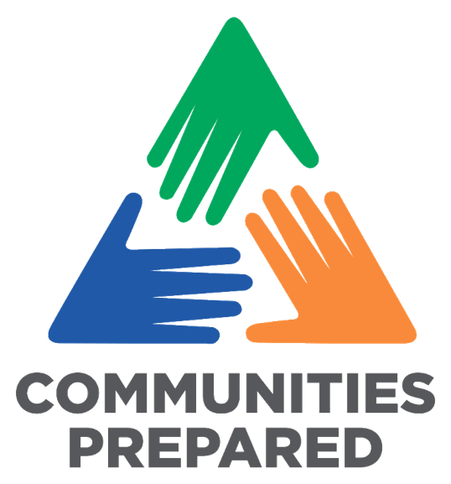
Page 23: Checklist for Getting Started
Page 26: Community Emergency Plan Details
https://www.communitiesprepared.org.uk/london-community-resilience-toolkit/

Decide if you are approaching this collectively or individually.
Collectively is ideal so you can tap into knowledge and wisdom outside of your group or organisation.
Seek to understand what mapping already exists.
Often others have completed a mapping exercise before, which you could use and potentially build on to save a lot of time.
How are you coming together?
Are you using an existing meeting or event? Or a specific time and location, or are you meeting virtually?
Allocate enough time for collaboration and discussion.
This isn’t about getting to the solution quickly, it’s about developing and creating a clear map of your community, in a way that works for you, that also helps to build new relationships.
Decide how you want to develop your community map.
You know your community best – how do they like to engage? Make sure you have the necessary tools and resources.
- Creative activities e.g. drawing diagrams and using post-it notes
- Practical action e.g. talking a walk around the local area.
- Desk-based research and speaking with others.
- Facilitated conversations or workshops with your groups.
- If meeting virtually, research and trial the best software before you meet.
Think about how you kick start the session to grab people’s attention.
You might want to set the scene with a local example of an emergency or scenario (use a real example if you can).
What would happen:
- If there was a flood on the high street or along a main road?
- If there was a fire in the park or in an important building?
- If there was a power outage or water outage?

Name of your community:
Key factors to consider in your community:
Start and completion dates of your plan:
Lead designated person and their contact details:

Page 31: Community Partners Table

What role will they play, or what resources do they have?
Organisation / Partner Name | Description of what they do | Contact Information | Role or Resources in an emergency
London Borough of Tower Hamlets Emergency Planning Team (Civil Protection Unit)  *Use this contact in the first instance to contact the officer who is ‘on call’ (individual officer contact details below) | First point of contact for coordinating ‘humanitarian assistance’ (welfare support for affected residents) during an emergency.  LBTH will coordinate support from other partner agencies, such as the British Red Cross: | Available 24/7:  020 7364 7070, option 6  Emergency.planning@towerhamlets.gov.uk | During Civil Emergencies only:  Can deploy resources and staff to manage/support an ‘Emergency Centre’ (place of shelter and support for displaced residents).  Can arrange for support from other partners e.g. Emergency Services, NHS and other voluntary organisations.
The British Red Cross Crisis Response Contact Centre | Phone line for emotional and practical support for individuals, families and communities.  Often activated by or works closely with the Council’s emergency planning team during an emergency response. | 0808 196 3651 (between 10am and 8pm Mondays and Thursdays, and between 10am and 5pm Tuesdays, Wednesdays and Fridays) | British Red Cross - What We Do - Emergency Response  Prepare for Emergencies Guidance
NHS 111 | Immediate medical triage/advice | 111  https://111.nhs.uk/ | Medical advice, mental health support, prescriptions/replacement medications, referral/signposting
UK Power Networks | Emergency Line | 0800 311 8074 | Provide updates on incidents and restoration time
Cadent Gas | Emergency Line | 0800 111 999 | Provide updates on incidents and restoration time
Thames Water | Emergency Line | 0800 316 9800 | Provide updates on incidents and restoration time
24hr Floodline Service | Receive and check Flood Warnings | Telephone: 0345 988 1188  Textphone: 0345 602 6340  https://check-for-flooding.service.gov.uk/ | Shares Flood Warnings when issued.
Samaritans | 24/7 emotional support helpline | 116 123 | Provides emotional support to those in distress or crisis, by phone or email.

Page 33: Community Risks and Impacts Table

List below the risks and impacts that you want to consider and include as part of your Community Emergency Plan. Remember to include the impacts that you might not necessarily experience yourself, considering how people from different backgrounds and with different abilities may be affected.
Risks | Impacts | Actions
Heatwave  A period of at least three consecutive days with daily maximum temperatures meeting or exceeding the heatwave temperature threshold (28 degrees in London) | - Impacts on health (dehydration, heatstroke, fatigue)  - Disproportionate impact on vulnerable residents  - Reduced air quality  - Increased water pipe bursts (due to pressure on system) leading to water outage  Residents at increased risk:  Elderly, those with chronic illnesses, those unable to adapt behaviour to keep cool (e.g. infants) and those overexposed to heat (top floor flats, those that work outdoors) | - Sign up to receive UK Health Security Agency Weather Health Alerts  When Weather Health Alerts are issued:  - Refer to the 'Beat the Heat' Guidance  - Refer to the Action Card for Voluntary and Community Organisations  - Check on neighbours/residents  - Consider arrangements to procure bottled water (in case of water outage)
Drought  Period of prolonged dry weather characterised by a shortfall of water after a period of low rainfall. | - Restrictions on water use  - Reduced household water pressure  - Water supply outages  - Economic impact on residents (higher bills, impact on businesses)  - Air quality (loss of green spaces and increased dust) | - Stay informed on updates issued by water suppliers  - Follow official guidance  - Check on neighbours and vulnerable residents
Flooding  Check flood risk of an area here | - Property damage  - Temporary homelessness  - Water contamination  - Basement and Ground floor properties at highest risk | - Sign up to Flood Warnings  - Sign up to Severe Weather Warnings  - Review Gov UK Prepare guidance  - Do not enter floodwater  - Emergency Services and the Local Authority will coordinate evacuations
Water Supply Disruptions  Potential causes: mains water burst, planned or emergency maintenance, severe weather (freezing temperatures or drought) | - Loss of drinking water  - Lack of sanitation  - Health risk to those with medical needs  - Need to consider residents less able to purchase bottled water / plan for distribution of water delivered during an incident | - Sign up to Thames Water’s Priority Services Register where eligible  - Review Thames Water’s Prepare for an Incident guidance  - Utilise emergency contacts above during an incident
Power Supply Disruptions  Local, Regional or National  Potential causes: Severe weather, damage to infrastructure, maintenance, national energy shortage | - Inability to heat or cook  - Loss of perishable food in fridges and freezers  - Lack or loss of internet or mobile signal  - Medical equipment failure  - Impacts on water supply and sanitation | - Sign up to UK Power Network Priority Services Register where eligible  - Consider offline storage of emergency plans and contacts  - Review Gov UK Prepare: Power Outage guidance  - Prepare resources e.g. torch, wind up radio, bottled water, non-perishable food, spare batteries
Residential Fire | - Property damage and loss of personal items  - Evacuation and temporary homelessness  - Poor air quality | - Support vulnerable residents (share information with emergency services and local authority)  - Potential use of Community Centres as a ‘Rest Centre’ or ‘Humanitarian Assistance Centre’ (information point)
Terrorism/Civil Unrest | - Damage to or loss of properties and community facilities  - Public fear and uncertainty | - Police will lead the response  - Follow official communications
Pandemic | - Disproportionate impact on the vulnerable  - Isolation or ‘shielding’ of elderly/those with chronic illness  - Impacts on mental health | - Review lessons from 2020 pandemic when planning support  - Check on neighbours/residents
Transport accidents  (road, rail, air) | Physical damage or long-term road closures, disruption in reaching work, school, or medical appointments.

Page 35: Key Skills for an Emergency

Key Skills for an Emergency

List below the people and skills you have in your organisation or network to help respond to an emergency or major challenge in your community.
Key Skill in an emergency | People who have this skill | Contact details | Availability

Gaps Identified | Actions to address gaps: | Responsible | Completed
1)
2)
3)
4)
5)
6)
7)
8)
9)
10)
11)
12)
13)
14)
15)
16)
17)
Page 37: Skills and Resources Gaps
Emergency Contacts
Fill out the below table of key emergency contacts you need to activate your plan.
Organisation | Contact Details | Role and Responsibility
Example: Knowheresville Local Council | Example: 0202 111 2222 www.knowheresville.gov.uk/emergencies | Example: The local council will coordinate local response to an emergency, including supporting residents.
Page 41: Emergency Contacts

Page 43: Practice and Exercise Log

Practice and Exercise Log
Use the table below to capture the learnings from tests and practices of your Community Emergency Plan
Practice or exercise date | What went well? | What needs improving? | Key actions from learning
Example: 1st December 2024 | Example: Communication relevant people worked and happened quickly | Example: More understanding needed of what to do / not do in an emergency. | Example: Increase knowledge and awareness of hazards and the actions to take.
Page 62: Your Reflection

How did you approach the toolkit and the tasks?
What was something that you learnt?
What was something that you enjoyed?
If you were going to start the process again, what would you do differently?
When are you next going to review the toolkit and update your Community Emergency Plan?
Page 63: Activities and Actions you are taking forward

Action/ Activity
Action/ Activity
Action/ Activity
Action/ Activity
Action/ Activity
Action/ Activity
Action/ Activity

